**Project Feasibility Report**

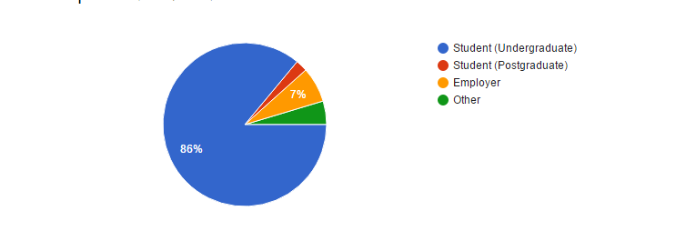

**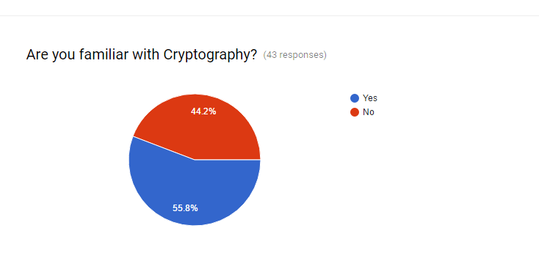  
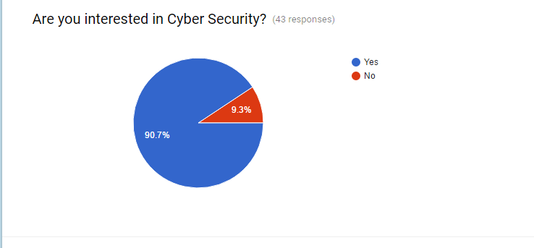**

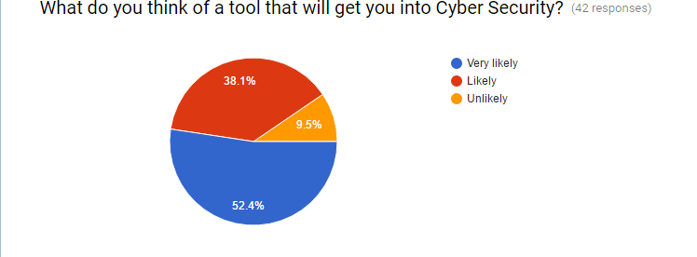

**2.1 Executive Summary**

Inferable from the reason that transmission media are temperamental, so sharing or transmitting information in ordinary mode is ordinarily perilous. The information should be adjusted in a manner that, despite the fact that it can be perused by any unapproved client, the data can't be extracted. So we have thought of sending documents and instant messages in a scrambled configuration utilizing the encryption tool. This apparatus additionally helps us find out about the points of interest of cryptography.

**2.2 Software Feasibility**

The product required for the usage of this software project and the stages required for this product to run, are promptly accessible in the business sector at sensible costs. To do this task we, initially need to execute the encryption calculation and adapt that to customer server strategy. The project programming will be done utilizing JAVA dialect and it is plausible.

**2.3 Time Feasibility**

The calculations can be executed and keep running progressively, so the other thing we need to do is to set up a customer server strategy in the product, so that the customer can send the server documents and messages in an encoded position. We can comprehend that the venture should be possible in a restricted time and could be kept running in a constant framework so that the time can be effectively overseen for the framework.

**2.4 The Market**

The business sector for this kind of programming is rich on the grounds that everybody needs security for their data and with encryption systems, information can be secured at a specific level. Additionally, anybody with no earlier information about cryptography can utilize this apparatus to find out about it and see its usage.

**2.5 Cost Feasibility**

It can be executed in a minimal effort and the necessities are not high, so the product creation cost would be essentially low. Consequently the customers can bear the cost of this product, as it is cheap.